

OnderzoeksverslagWEEK 3

Bryan Baan
Chanan van Ooijen
Yusuf Syakur
Lars Veenendaal
Mitchell Werensteijn
TIV2A
Themeopdracht 7
Een verzameling van informative over extern bestuurbare wasmachines.

Table of contents
Smoothing 3
Laplacian 5
Gaussian blur 7
Remove noise filters 9
Median filter 9
Mean filter 11
Edge detection 13
Sobel edge detection 14
Canny edge detection 15
Convolving 18
Enhancement 19
Histogram equalization 19
Unsharp masking 20

Smoothing
Smoothing in general is very easy to explain. Its purpose is to smoothen the image create a better base for other forms of image processing. Here is an example of a picture that is smoothed:
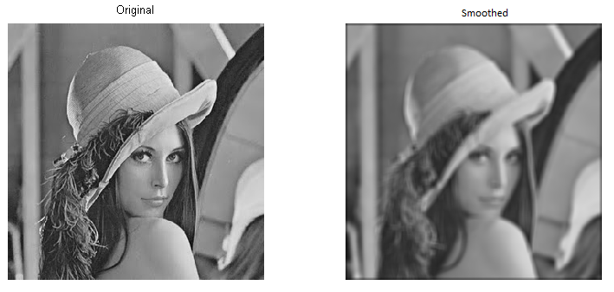
Figure 1 – Lena original image and smoothed
On the left side you can see the original image. All the pixels are the color they should be and you can see every edge very clear. On the right side you can see the same image, but with smoothened edges. This technique is used to remove certain noise from a picture. When this noise is removed, you can work with the new data.
Smoothing can be done with certain smoothing masks. These masks can be 3x3, 5x5 and bigger. These masks use the values of the pixels around the one you’re editing and that way he can calculate the needed value for the pixel you want to edit. If you do this for all the possible pixels (you cannot do this for the pixels on the edge of the image since you’ve got masks of minimal 3x3) you will get a new image looking like the second in the picture above. As mentioned before, your smoothing mask can vary. The bigger your mask is, the smoother the result will be.
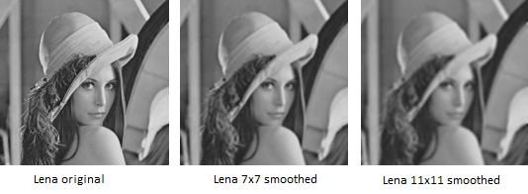
Figure 2 – comparison with different smoothing masks
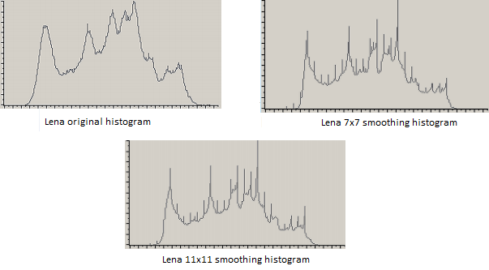
Figure 3 – Histogram for each image
Looking at these histograms you can definitely see difference between the pictures, smoothened or not. The amount of pixels with a certain top value (the tops in the histogram of the original picture) decreases and the values will all be closer to their neighboring values.
But what calculations are done to get these results? There are several algorithms to calculate the needed values. Two of which will be explained here, the Laplacian method and the Gaussian blur method.

Laplacian
The Laplacian method is an algorithm to detect edges and make a move when one is detected. It selects the 2 neighboring pixels and detects their value. Then the algorithm will solve a simple sum to see if the value of the Laplacian will change from above 0 to below 0, or the other way around. An example and possibly a better explanation will follow.
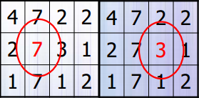
Figure 4 – Calculate Laplacian
Looking at figure 4 we see 2 different grids of 4x4. Imagine you’re currently standing on the spot of the red 7 in the first grid. You can calculate the Laplacian of this picture by finding out what the values are of the neighboring pixels. In this case they are 2 and 3. The calculation that needs to be done is as follows: 3 + 2 - 2∙7 = -9. The first piece of the puzzle, (3 + 2) is the sum of the values of the neighboring pixels. The second piece is the calculation of the value of the current pixel, 2 * 7. The answer of this sum shows that the laplacian of this pixel is -9. Now we move on to the next pixel. The neighboring pixels have a value of 7 and 1, and its own value is 3. Making the calculations (7+1 – 2*3 = 2) will show that the answer is 2, so the laplacian of this pixel is 2. We can see that the laplacians of this pixel and the previous one are -9 and 2. The values differ from below 0 to above 0. That means that an edge is detected at the pixel with value [3].

The good part about this formula is that it can tell you exactly where in the pictures you can find edges. This formula, however, also has a bad part. If a picture has noise in it, for instance salt and pepper noise, the formula will detect edges all over the place. In other words, this method can be used on a noisy picture but don’t expect accurate results. As an example of what will be the result of this, here are some pictures.
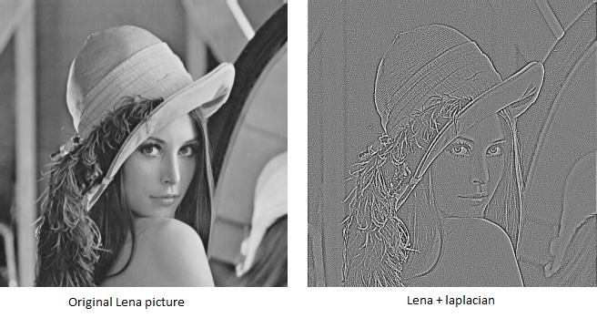
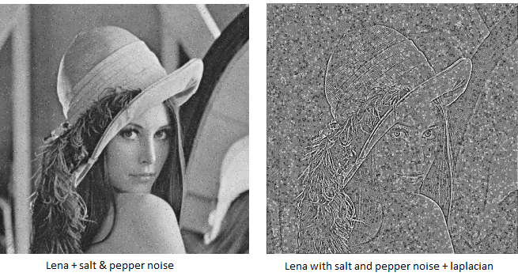
Figure 5 – Lena used with laplacian with and without salt & pepper noise

Gaussian blur
The Gaussian blur method is a simple way of making a picture look smoother. The Gaussian blur method is also a lot more efficient than other forms of smoothening, including the one discussed above. This method is used to remove noise so the user can work with the image. This method, just like the one discussed before, sets the value of a certain pixel depending on the values of its neighboring pixels.
The formula is explained very simple: the value of the pixel you’re currently standing on will be adjusted depending on the weighted average of the pixels around the current one. The weighted average is the amount of times the pixel value will be weighing by calculating the average. This may sound difficult, but it actually is very simple. Looking at the following picture you can see something like a mountain.
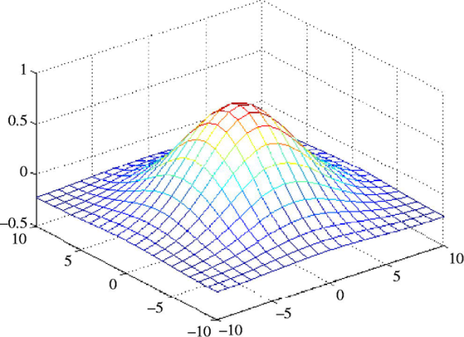
Figure 6 – Formula gaussian blur
Looking at this mountain you can say that the top of the mountain is the pixel located at 0,0 (current pixel). Let’s say this middle pixel weighs 100 (like 100%). The more you move down the hill of the mountain, the less the pixels will weigh. The pixels at 50% of the mountain will weigh 50 and so on.
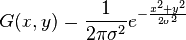
Using the formula shown above we can calculate the new pixel value. The formula works pretty clear: The sigma (σ) represents the blurring factor. The bigger the number, the more blur you create. The e in this formula is a constant value, just like Pi, but with a different value (about 2.7182). The x represents the horizontal pixel value which, together with y (being the vertical pixel value), can be used to target a specified pixel. This means that the x and y represent the pixel you wish to change. If you give them both the value 0, you are standing on the center pixel (the pixel you’re editing). The x^2 + y^2 represent the weight of the pixels in the neighborhood. The farther you move away from the center pixel, the less weight the pixel has.
The advantages of this method:
- It is an efficient and effective solution to reduce noise
- The edges and weighing makes sure the pixels at the edges are less blurred
The disadvantages of this method:
- It takes a lot of time
- It removes unrecoverable details in a picture

Image sources:
http://www.cosy.sbg.ac.at/~pmeerw/Watermarking/lena_gray.gif
https://cursussen.sharepoint.hu.nl/fnt/55/TCTI-V2VISN1-13/Studiemateriaal/Les-slides/Les%202%20-%20Neighborhood%20operations.pdf

Information sources:
http://www.mathworks.com/matlabcentral/answers/64683-advantages-disadvantages-of-using-and-not-using-a-gaussian-filter
http://en.wikipedia.org/wiki/Gaussian_function
http://en.wikipedia.org/wiki/Gaussian_blur
http://homepages.inf.ed.ac.uk/rbf/HIPR2/gsmooth.htm
http://en.wikipedia.org/wiki/Smoothing
http://xn--80afqipfk7a.xn--p1ai/2007/proceedings/Papers/Paper_70.pdf
http://en.wikipedia.org/wiki/Laplacian_smoothing
https://cursussen.sharepoint.hu.nl/fnt/55/TCTI-V2VISN1-13/Studiemateriaal/Les-slides/Les%202%20-%20Neighborhood%20operations.pdf

Remove noise filters
There are different ways to remove noise in an image. Two algorithms that are very effective against impulse noise (also known as salt&pepper noise) are median filter and mean filter. We will explain how each filter works and what the advantages and disadvantages are.

Median filter
Median filtering is a method used to remove noise from images. Median filtering is an effective method to remove impulse noise (like salt&pepper). This method works by walking through the image pixel by pixel and replacing each pixel value with the median value of neighbouring pixels. For every single pixel we place a window over the pixel we want to change. If we use a 3x3 median filter the window size will be 3 by 3 (See Figure 1).
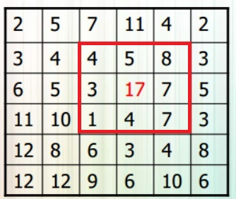

Figure 7. https://cursussen.sharepoint.hu.nl/fnt/55/TCTI-V2VISN1-13/Studiemateriaal/Les-slides/Les%202%20-%20Neighborhood%20operations.pdf (sheet 76)

Let’s take a look at Figure 7. As you can see in figure 7 we want to change pixel with pixel value 17 (we placed a window or neighbourhood over pixel with pixel value 17). Now we have to save all the 9 pixel values into a list and sort the list from low to high. The output will be: [1, 3, 4, 4, 5, 7, 7, 8, 17]. Because the list length is an odd number we can take the middle-ranked pixel value (as we can see in Figure 2). We now have the median value and replace pixel value 17 by pixel value 5. You will need to do this for every single pixel in your image. In this example we used a 3x3 median filter but if we used a 4x4 median filter the calculation will be a bit different. If we want to change a pixel with a 4x4 median filter the list will have a length of 16. Because there isn’t a middle-ranked pixel we will have to take the length (16 in this case) divide it by 2 (that will be 8). We now look to the value that is stored in element 8 and sum that with the next element (9) and divide that by 2. We now have the median pixel value.
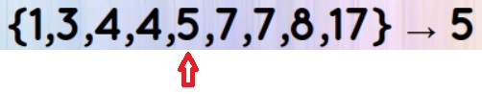
Figure .8 https://cursussen.sharepoint.hu.nl/fnt/55/TCTI-V2VISN1-13/Studiemateriaal/Les-slides/Les%202%20-%20Neighborhood%20operations.pdf (sheets 76)

The median filter will cost a lot of performance because for every single pixel you have to make a sorted list. There are different ways to sort a list. Quicksort will be fast, but not for small lists. If you only use a 3x3 neighbourhood Insert sort will be the fastest way to get the job done. The smartest way to find the median value, you can make a histogram of the neighbourhood. Figure 3 shows execution times for median filter of a 515x512 image. Another problem is that edges won’t be changed because we can’t place a window over the edge pixels (See Figure 10).

Advantages:
- It is very simple to understand
- Reduces noise
- The median filter will cause minimal blurring
- If there is an unusual pixel value in the neighbourhood, it won’t have effect on the median pixel value
Disadvantages:
- Less effective in removing other noise then impulse noise
- As we told earlier, it cost a lot of performance
- Reduces detail
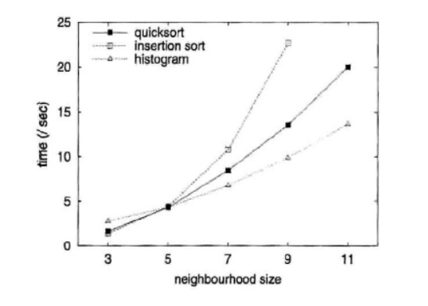
Figure 9. https://cursussen.sharepoint.hu.nl/fnt/55/TCTI-V2VISN1-13/Studiemateriaal/Extra%20Literatuur/Neighbourhood%20operations.pdf (p.180)

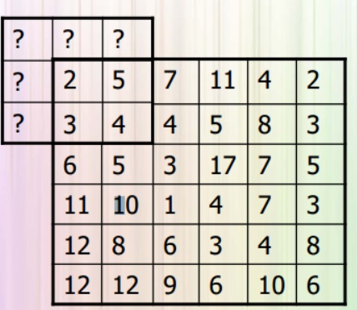
Figure 10. https://cursussen.sharepoint.hu.nl/fnt/55/TCTI-V2VISN1-13/Studiemateriaal/Les-slides/Les%202%20-%20Neighborhood%20operations.pdf (sheet 23)

Mean filter
The mean filter has many similarities with the median filter. Just like median filtering the mean filter is an effective way to remove impulse noise (for example salt&pepper). This method works by walking through the image pixel by pixel and replacing each pixel value with the median value of neighbouring pixels. For every single pixel we place a window over the pixel we want to change. If we use a 3x3 median filter the window size will be 3 by 3 (See Figure 11).
Figure 11. https://cursussen.sharepoint.hu.nl/fnt/55/TCTI-V2VISN1-13/Studiemateriaal/Les-slides/Les%202%20-%20Neighborhood%20operations.pdf (sheet 76)

Let’s take a look at Figure 11. As you can see in figure 11 we want to change pixel with pixel value 17 (we placed a window or neighbourhood over pixel with pixel value 17). Now we have to save all the 9 pixel values into a list. The list will contain the following numbers: [4, 5, 8, 3, 17, 7, 1, 4, 7]. For getting the mean pixel value we have sum all the elements and divide the sum by the number of elements (9 in this case). In this case the sum is 56 and if we divide it by 9 we will get 6,2222. Because the value is an integer the mean pixel value will be round to 6. We now have the mean value and replace pixel value 17 by pixel value 6. You will need to do this for every single pixel in your image.
A problem is that edges won’t be changed because we can’t place a window over the edge pixels (See Figure 10).
Advantages:
- It is very simple to understand
- Reduces noise
- Faster than median filter because you didn’t have to sort the list for each pixel
Disadvantages:
- Less effective in removing other noise then impulse noise
- If there is an unusual pixel value in the neighbourhood, it will have effect of the mean filter value
- Reduces detail

Edge detection
In Vision, an edge is the boundary between an object and its background. If edge detection is executed with precision, all the objects can be located and identified in the picture. Objects such as an area, perimeter, shape, etc. The purpose of detecting sharp changes is to capture important objects and reduce the amount of data to be processed that is irrelevant.
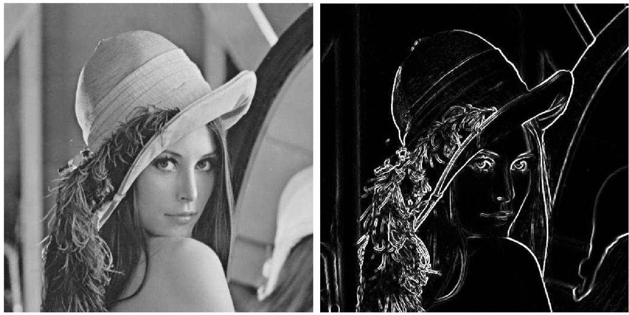
Figure 12 – Lena with edge detection
The figure above shows the well-known Lena. On the left is the original picture whereas the right shows edge detection. As said before the information that may be regarded as less relevant is filtered out, while preserving the important structural properties of Lena. Edge detection is one of the fundamental steps of computer vision techniques. A lot of edge detection algorithms are out there. Two of those chosen randomly will be discussed next. These are the Sobel Edge Detection and the Canny Edge Detection.

Sobel edge detection
The Sobel operator performs edge detection by looking at the image gradient. An image gradient is a change in intensity (or color) of an image. An edge in an image occurs when the gradient is greatest and the Sobel operator makes use of this fact to find the edges in an image. It calculates the approximate image gradient of each pixel by convolving the image with a pair of 3x3 filters. These filters estimate the gradients in the horizontal (x) and vertical (y) directions. The magnitude of the gradient is simply the sum of these two gradients. The most common masks to use for the Sobel operator are:
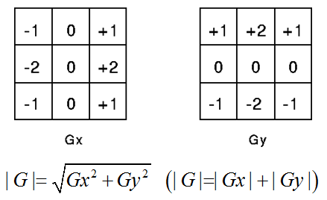
Figure 13 – Sobel 3x3 masks
The values of the mask can be amplified to detect even more edges. The important part of these masks is that the middle row(x) or column(y) must be zero. A normalized gradient picture is the result of each of these masks. The results for applying these masks are shown on the image below.
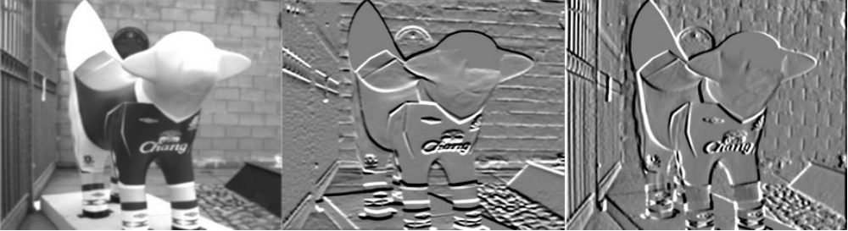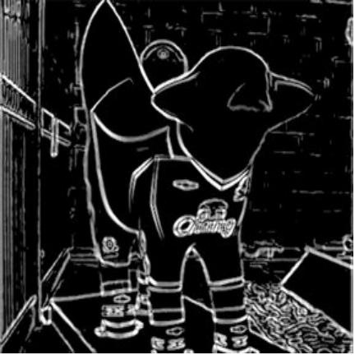The result for the Gy is shown in the middle whereas the result for the Gx is shown on the right. Note that Gaussian blur was used for the original image to reduce noise. If both of these gradient are put together then it will show the edges as the picture on the right.
An advantage of using the Sobel operator is that it gives an estimate of edge direction as well as edge magnitude at a point which is more informative and is of considerable use n later processing. A disadvantage of the Sobel edge detector is that the response to a step edge is present over either two or three pixels width, dependent on the precise position of the step relative to the pixel grid.

Canny edge detection
John Canny came up with a theory about optimizing an edge detector. It should satisfy these three conditions:
- The edge detector should respond only to edges and should find all of them: no edges should be missed.
- The distance between the edge pixels as found by the edge detector and the actual edge should be as small as possible.
- The edge detector should not identify multiple edge pixels where only a single edge exits.
To meet these three conditions, John went step by step to simplify and execute the three conditions.
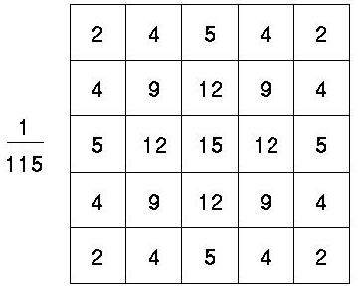
Figure 14 – Gaussian 5x5 mask
The first step was to add a Gaussian mask. Because the Canny edge detector is susceptible to noise present in raw unprocessed image data, the noise should be removed first. The result of using a Gaussian filter is a blurred version of the original image. However not a single noisy pixel will be present. How large the Gaussian mask should be depends on the size of an image. Using a larger mask will cause details to be lost forever while minimalizing the possibility of noisy pixels. Figure 14 shows an example of a gaussian 5x5 mask.
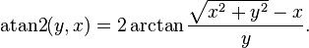
The second step is to search for the edge strength. This will be done by using the mentioned Sobel operator. The canny edge detection is not satisfied with the two filters (x,y) the Sobel had just created. It also needs to know the direction of the edge. This will be done by using the atan2 function (using Gx and Gy as the x,y). Now we have four angles representing vertical, horizontal and the two diagonals.
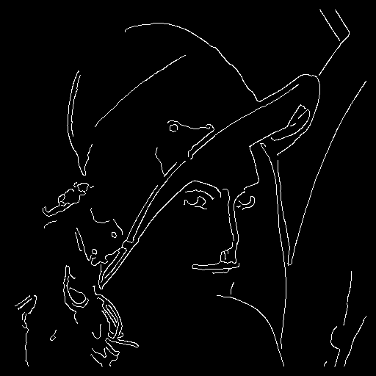
Figure 15 – Lena after non-maximal suppression.
The third step is to use non-maximal suppression. This means the edges will be thinned out. This process results in one pixel wide ridges from thick edges. It requires horizontal and vertical gradients and the magnitude of gradients (Sobel). The basic idea of non-maximal suppression is that: If a pixel value is not greater than its neighbored pixels, then the pixel is not the edge (the value is set to zero). During this process, it also needs to know the direction of the gradient vector in order to find 2 neighbor pixels on the same direction, then to compare them with the current pixel. That is why the 4 filters were needed in the second step. Figure 15 shows Lena with one pixel edges. Using non-maximal suppression has put the basic edges.
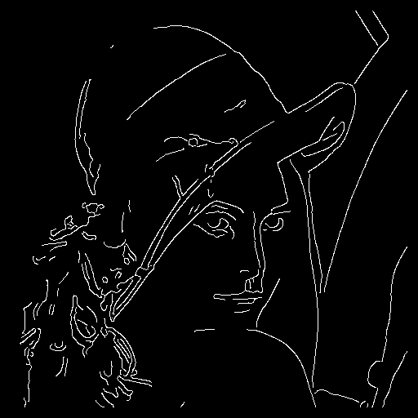
Figure 16 – Lena after the last step
The last step is to perform hysteresis threshold. It is needed to remove the weak edges and connect the splitted edges. To connect the edges it compares each pixel with the 8 surrounding neighbors. If the neighbor is greater than the low threshold that has been input, then it will also become an edge. The range of threshold is: 0 < tLow < tHigh < 1. Choosing a tLow and tHigh is easier since non-maximal suppression was applied. Figure 16 shows Lena after the Canny edge detection.
The advantages for using the Canny algorithm are that there is a better detection than most algorithms even when in noise conditions. The disadvantage of using this algorithm is that there are so many steps to take that it will cost a lot of performance if executed on a computer.

Convolution
Convolution is a important concept in a lot of different fields aswell in the field of signal processing and analysis. Convolution is able to create an output out of any input signal and an impulse response.
In convolution a calculation is performed at a pixel which is set by the sum of the neigbouring pixels.
This could be a + sign a 3x3 matrix or bigger depending on the situation.
X
Example neighborhoods
X

The square or neighborhood is also know as the convolution kernel. And the size of this kernel will dictate the calculations that will have to happen.
Then there is the impulse response which is what the system is going to run against the current values and will be better understandable as the filter.
A certain setting of the impulse could be a low pass filter where in a different one could be a high pass filter.
More on those filters later in this chapter.
Convolution definition comes out of the mathematical domain.
And its equation is as follows:
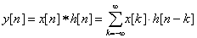
x[n] is an input signal
h[n] is the impulse response
y[n] is output
* is the notation for convolution.
Important is that we multiply x[k] by the terms of time-shifted h[n] and add them up.
Key to understanding convolution is understanding the way the impulses are being handled.

1D convolution
For this example we are given the following:
x[n] = { 3, 4, 5 } ← is an input signal
h[n] = { 2, 1 } ← is the impulse response
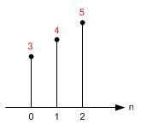
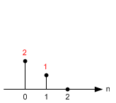

Input: x[n]
Impulse Response: h[n]
And with this information we are going to calculate the output step for step.
For the calculation of a straight line we don’t have to think about the kernel just yet.
y[0] = x[k] · h[0-k] = x[0] · h[0] = 3·2 = 6
y[1] = x[k] · h[1-k] = x[0] ·h[1-0] + x[1] ·h[1-1] = 3·1+4·2 = 11
y[2] = x[k] · h[2-k] = x[0] ·h[2-0] + x[1] ·h[2-1]
+ x[2] ·h[2-2] = 3·0+4·1+5·2 = 14
y[3] = x[k] · h[3-k] = x[0] ·h[3-0] + x[1] ·h[3-1]
+ x[2] ·h[3-2] + x[3] ·h[3-3] = 0+0+5x1+0 = 5
y[4] = x[k] · h[4-k] = x[0] ·h[4-0] + x[1] ·h[4-1]
+ x[2] ·h[4-2] + x[3] ·h[4-3]
+ x[4] ·h[4-4] = 0+0+0+0+0 = 0
As you might as well have spotted there is no use to continue after y[4] they will all be 0’s.
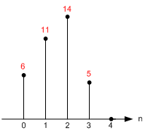
Output: y[n]

2D Convolution
Keep in mind that everything is based on column and row.
Just to be clear that is horizontal and then vertical.
Notice that the origin of impulse response is always centered. (h[0,0] is located at the center sample of kernel, not the first element.)

Let's start calculate each sample of the output one by one.
First, flip the kernel, which is the shaded box, in both horizontal and vertical direction. Then, move it over the input array. If the kernel is centered (aligned) exactly at the sample that we are interested in, multiply the kernel data by the overlapped input data.
The accumulation (adding these 9 multiplications) is the last thing to do to find out the output value.

Note that the matrices are referenced here as [column, row], not [row, column]. M is horizontal (column) direction and N is vertical (row) direction.

For this example we are using the following:
1 | 2 | 3
4 | 5 | 6
7 | 8 | 9

Input x[n] Impulse Response: h[n]
-1 | -2 | -1
0 | 0 | 0
1 | 2 | 1

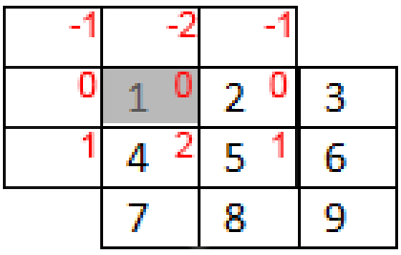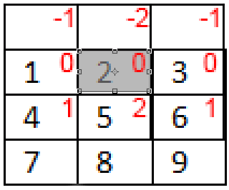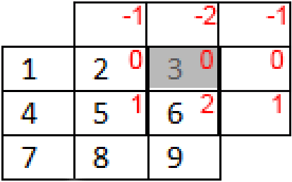
Y[0,0] Y[0,1] y[0,2]

The impulse response is always centered around the value that we want to change.
This means that the value that your are calculating the value of h[0,0] is centered on that value.( This is one in the example).
However for the value x[0,0] is almost the first value top left. (in this example that is 1.)
For calculating y[0,0] we need the following.
Y[0,0] =
X[-1,-1] · h[1,1] + X[0,-1] · h[0,1] + X[1,-1] · h[-1,1]
+ X[-1,0] · h[1,0] + X[0,0] · h[0,0] + X[1,0] · h[-1,0]
+ X[-1,1] · h[1,-1] + X[0,1] · h[0,-1] + X[1,1] · h[-1,-1]
0x1 + 0x2 + 0x1
+ 0x0 + 1x0 + 2X0
+ 0x1 + 4x-2 + 5x-1 = -13

Y[1,0] =
X[0,-1] · h[1,1] + X[1,-1] · h[0,1] + X[2,-1] · h[-1,1]
+ X[0,0] · h[1,0] + X[1,0] · h[0,0] + X[2,0] · h[-1,0]
+ X[0,1] · h[1,-1] + X[1,1] · h[0,-1] + X[2,1] · h[-1,-1]
0x1 + 0x2 + 0x1
+ 1x0 + 2x0 + 3x0
+ 4x-1 + 5x-2 + 6x-1 = -20

Y[2,0] =
X[1,-1] · h[1,1] + X[2,-1] · h[0,1] + X[3,-1] · h[-1,1]
+ X[1,0] · h[1,0] + X[2,0] · h[0,0] + X[3,0] · h[-1,0]
+ X[1,1] · h[1,-1] + X[2,1] · h[0,-1] + X[3,1] · h[-1,-1]
0x1 + 0x2 + 0x1
+ 2x0 + 3x0 + 0x0
+ 5x-1 + 6x-2 + 0x-1 = -17

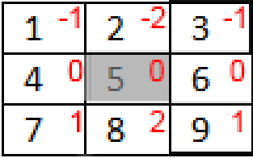

Y[1,1] =
X[0,0] · h[1,1] + X[1,0] · h[0,1] + X[2,0] · h[-1,1]
+ X[0,1] · h[1,0] + X[1,1] · h[0,0] + X[2,1] · h[-1,0]
+ X[0,2] · h[1,-1] + X[1,2] · h[0,-1] + X[2,2] · h[-1,-1]
1x1 + 2x2 + 3x1
4x0 + 5x0 + 6x0
7x-1 + 8x-2 + 9x-2 = -24 =
So far we have calculated the following values and if you see the pattern in the calculations you can finish the rest which gives you the end result.

-13 | -20 | -17
 | -24

Input x[n] Impulse Response: h[n]
-13 | -20 | -17
-18 | -24 | -18
13 | 20 | 17

-9 + -16 + -7 -32
8 24

Lowpass =
1 1 1
1 1 1
1 1 1
------
9
1 | 2 | 3
4 | 5 | 6
7 | 8 | 9
Highpass
-1 -1 -1
-1 8 -1
-1 -1 -1

Enhancement
An enhancement algorithm manipulates an image to improve its information. The information an image contains will be made more visible. For example the colors and brightness can be balanced to improve the details in an image or the image can be sharpened.

Histogram equalization
Histogram equalization is ideal to be used in situations where an image has been captured in bad conditions (weather/lighting). Histogram equalization is usually used to adjust the contrast in images.
First a histogram will be generated on a color channel. The histogram displays the intensity of a color value in the image:
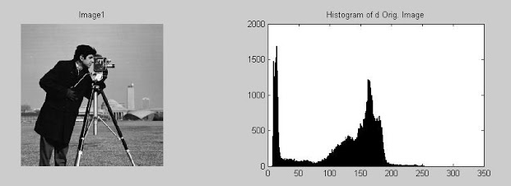
Figure 17 – Histogram on a 256 grayscale level
Secondly all color intensities will be equally distributed over the histogram, which gives us an image with a higher contrast. All color values will be recalculated by looking in the histogram table.
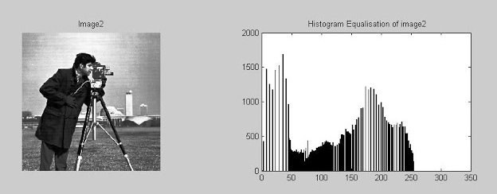
Figure 18 – Equalized histogram on a 256 grayscale level
Advantages
- Simplicity of the algorithm.
- The algorithm is invertible.
Disadvantages
- The brightness of high contrast images may be reduced.
- Often produces unrealistic effects with photos.
- The contrast of background noise may be increased while usable information is being reduced.

Unsharp masking
The unsharp masking algorithm is used to sharpen images. Unsharp masking works by combining information from three images.

The first image is the original image that has to be sharpened.
Figure 19 – Original image.
The second image is the unsharp mask; it is created by adding a Gaussian blur to the original copy and subtracting the blurred image from the original image.



Figure 20 – Original image minus the blurred copy equals the unsharp mask.

The third image is a copy of the original image with an increased contrast.
Figure 21 - Higher contrast version.


Finally the sharpened image can be created. For every pixel in the unsharp mask the brightness will be checked. If the brightness is 100%, the color value of the high contrast image will be used in the output image. If the brightness is 0% the color value of the original image will be used. For all other brightness percentages between 0 and 100, the color values of the original image and the higher contrast version will be mixed together into a new value. The output image is a sharpened image.
Figure 22 – The original image(left) compared to the sharpened image(right).
Advantages
- Image will be less blurry.
Disadvantages
- Not only the edges will be sharpened but everything will be sharpened.
- Noise will be sharpened.
Sources:
http://en.wikipedia.org/wiki/Histogram_equalization
Les 1 - Introductie, kleurruimte en histogrammen.pdf – Slides made by Arno Kamphuis.
http://amarsinghhpcs.blogspot.nl/2013/01/histogram-equalization-of-bmp-image-in-c.html
http://www.webopedia.com/TERM/I/image_enhancement.html
http://stackoverflow.com/questions/2938162/how-does-an-unsharp-mask-work
http://www.photokaboom.com/photography/learn/Photoshop_Elements/sharpening/USM_1.htm
Images source:
http://www.rocktheit.com/2012/09/matlab-program-to-apply-histogram.html
http://www.cambridgeincolour.com/tutorials/unsharp-mask.htm

